Services To Youth Project
MOBILE LIBRARY
Link Maya Feemster-Jones renovated the mobile library at Woodhill Elementary. Link Maya Feemster-Jones donated 400 books to the library. They allow 2 students per grade level to take books every week.

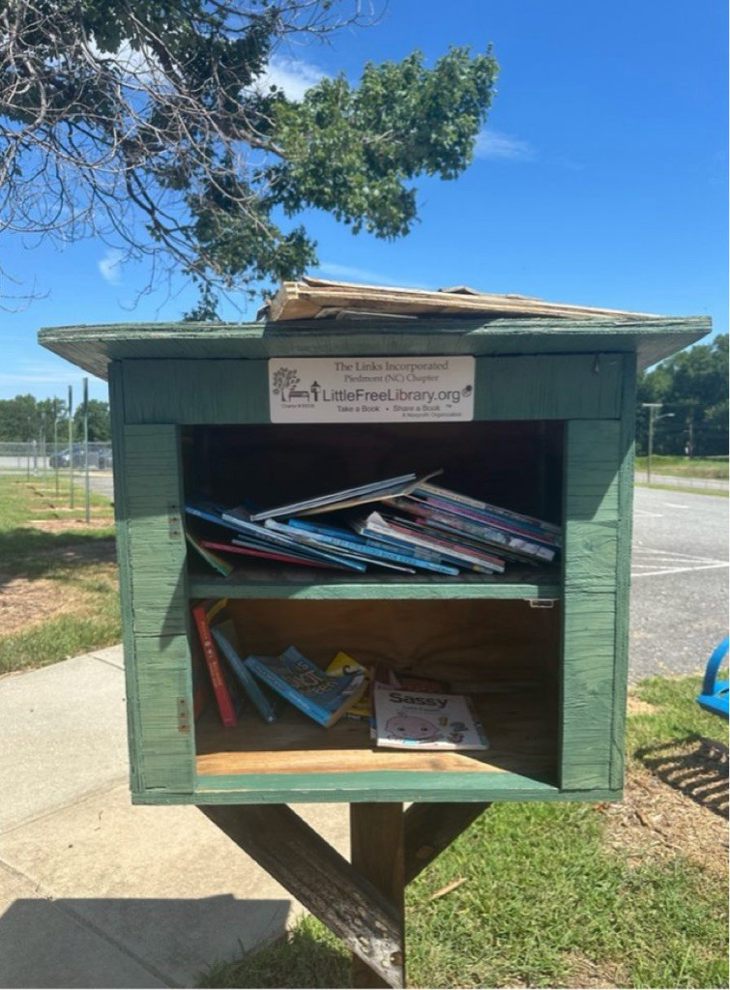
Before

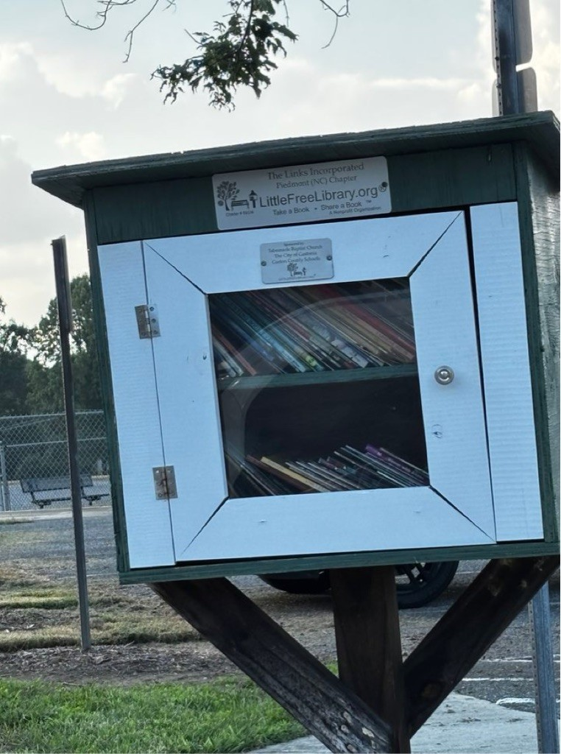
After

